Ramon Garcia Ramos Mechanical Engineering Portfolio
✉ ramonzgarcia12@gmail.com
 linkedin.com/in/ramon-garcia-ramos
✆ (706) 516 – 6085

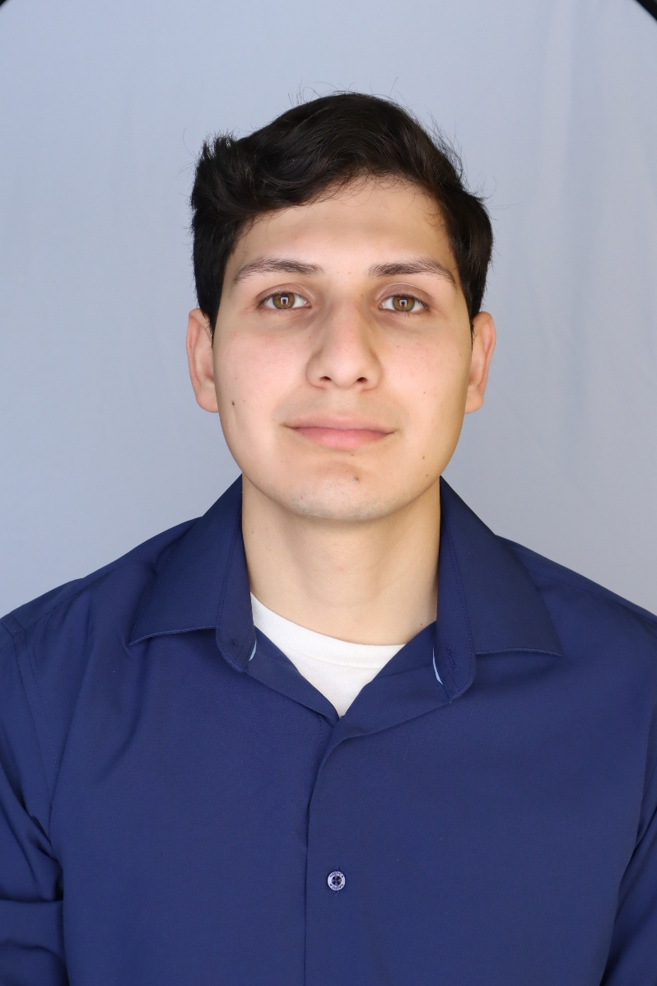

Table of Contents
PROJECT PAGE
Senior Design Capstone – Ceiling mounted parking deck drone system 3
Ping Pong Launcher 5
Pumpkin Launcher Trebuchet 7
Plaque Holder — Custom 3D-Printed Display Stand 9
Forward Arming and Refueling Point (FARP) — Georgia Army National Guard 10

Introduction
I’m a mechanical engineering student with a strong foundation in CAD modeling, simulation-driven design, and multidisciplinary problem-solving, supported by my experience in the Georgia Army National Guard. I approach engineering with a balance of technical precision, practical execution, and systems-level thinking.
My background includes work in mechanical design, structural analysis, UAV concepts, and engineering documentation, strengthened by participation in NASA’s L’SPACE MCA and L’SPACE LUCY programs. I’m driven by challenges that require creativity, analytical depth, and clear communication, and I’m committed to building solutions that are reliable, efficient, and grounded in real-world constraints.
About Me
I’ve always been drawn to machines, especially cars. What started as curiosity about how engines, suspensions, and aerodynamics work turned into a real passion for understanding and improving mechanical systems. I enjoy exploring how small design choices affect performance, and I’m always looking for ways to optimize, modify, or rethink how something functions.
That same curiosity extends beyond cars. I’m fascinated by innovative technology, spacecraft, aircraft, and the engineering behind systems that push the limits of what’s possible. Whether it’s new propulsion concepts, advanced materials, or emerging aerospace designs, I like diving into the details and learning how these ideas come together.
Outside of class, I’m usually researching new tech, studying mechanical systems, or working on projects that help me grow as an engineer. I take pride in being detail-oriented, reliable, and always improving, and I’m motivated by building things that work in the real world and move technology forward.

Senior Design Capstone- Ceiling-mounted parking-deck drone system
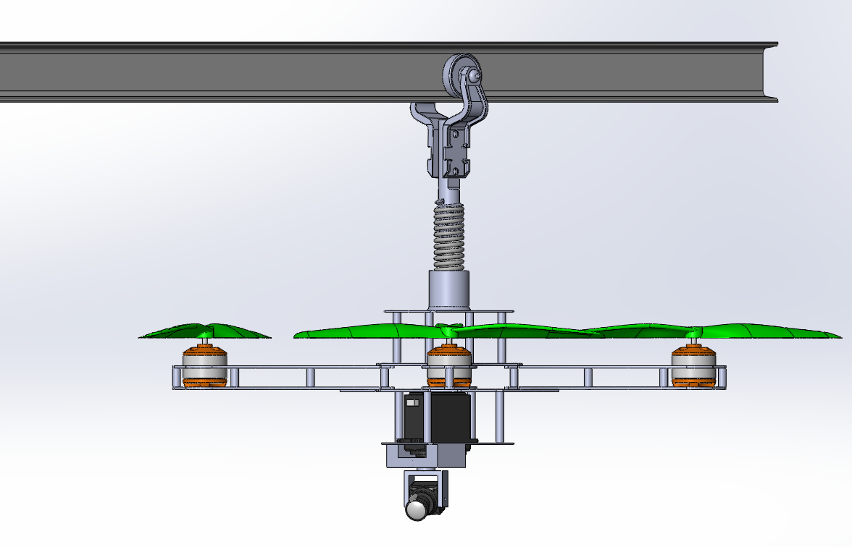 | 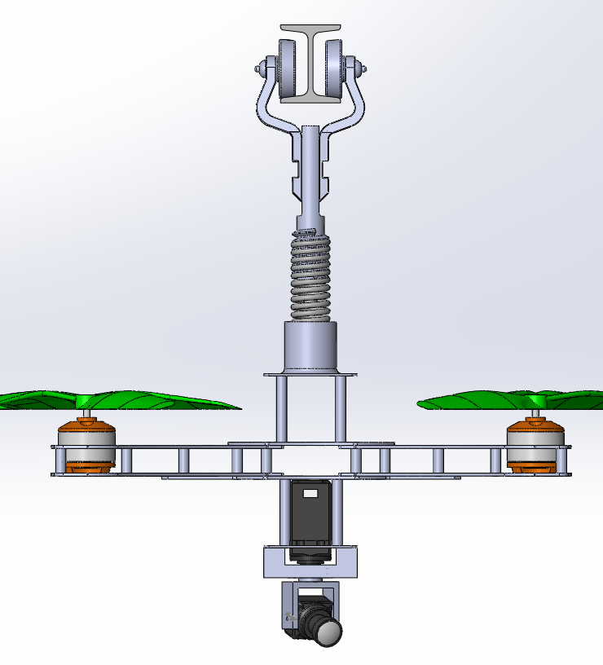

Role: Mechanical Design, Rail System Development, CAD Modeling, Structural Integration Status: Project currently in development (SD1 completed, SD2 in progress)
Overview
Our senior design project focuses on developing an autonomous ceiling-mounted drone system designed to scan multi-level parking decks and identify open parking spaces in real time. Unlike free flying drones, our concept uses a guided rail system mounted to the ceiling, improving safety, stability, and reliability in enclosed structures. The system aims to reduce congestion, improve parking efficiency, and provide real-time occupancy data to drivers through an app and digital signage.

This phase of the project centers on research, system architecture, CAD modeling, standards review, and feasibility analysis, with full prototyping planned for SD2.

Process
- Problem Definition & Research
  - Identified inefficiencies caused by drivers circling for open parking spaces
  - Reviewed patents, FAA regulations, and existing parking guidance technologies
  - Analyzed UAV-based parking detection research and safety considerations
- Mechanical System Concept Development
  - Designed a ceiling-mounted I-beam rail system to guide the drone along a controlled path
  - Created a trolley mount with vibration-damping concepts for stable camera scanning
  - Developed a drone-to-rail bracket for secure attachment and guided movement
  - Modeled the entire system in SolidWorks, including camera mount, frame, and rail interface
- Structural & Standards Integration
  - Applied ACI 318 and ACI 355 standards for concrete anchor design
  - Evaluated anchor spacing, embedment depth, and potential failure modes
  - Ensured compliance with FAA Part 107 weight and operational limits
- Electrical & Control System Planning
  - Outlined a sliding contact rail power concept for future continuous charging
  - Selected microcontroller, sensors, and relay modules for SD2 integration
  - Planned computer-vision implementation using YOLO-based parking detection
- Planning & Documentation
  - Developed a full Bill of Materials (BOM) and cost breakdown
  - Created a detailed lead-time schedule for SD2 fabrication and testing
  - Prepared engineering diagrams, CAD views, and system architecture documentation
Results & Key Takeaways
- Completed a full conceptual design of the ceiling-mounted drone system
- Produced detailed CAD models of the drone, rail system, trolley mount, and camera assembly
- Validated feasibility using ACI anchor standards, FAA regulations, and mechanical design principles
- Established a clear engineering path for SD2, including:
  - Structural simulations
  - Vibration and stability testing
  - Power delivery experiments
  - Automated movement and computer-vision integration
- Demonstrated strong teamwork across mechanical, electrical, and research domains

Ping Pong Launcher
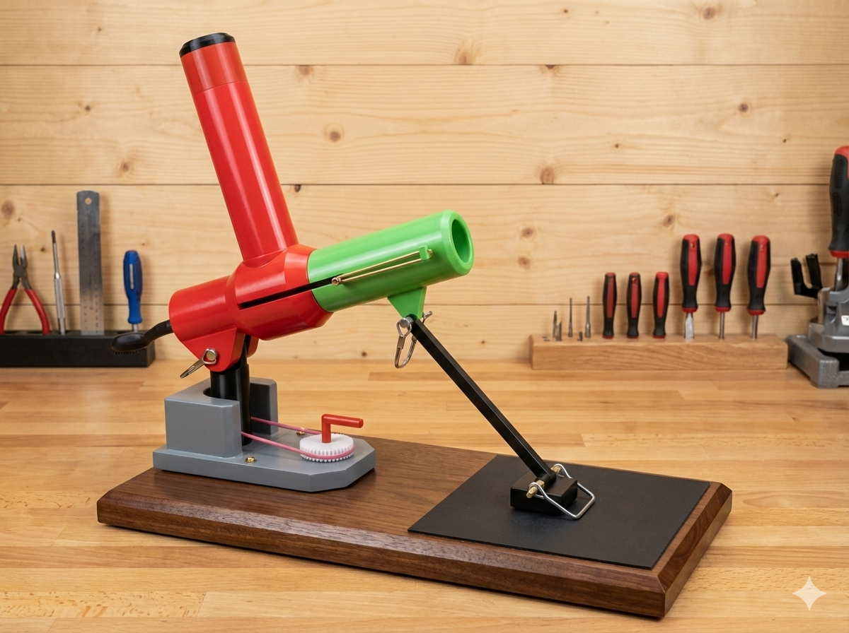

Role: CAD Modeling, Structural Analysis, Mechanism Development
Tools: SolidWorks, Shigley-based calculations, material selection, machine design principles
Overview
Designed a mechanically powered ping pong ball launcher capable of feeding, loading, and firing balls using a spring driven mechanism. The system incorporated gears, bearings, a feeding tube, and a rotating shaft to achieve consistent horizontal motion and controlled launches. The project emphasized mechanical design, structural analysis, and component selection based on real engineering standards.
Process
- Concept & CAD Design
  - Developed a launcher assembly with a spring-powered firing mechanism
  - Designed a gear-and-chain system to synchronize horizontal motion
  - Integrated bearings, shafts, and a feeding tube for sequential ball loading
  - Created section views to illustrate internal components and motion paths
- Structural & Fatigue Analysis
  - Beam deflection: Calculated shaft deflection using $I=\frac{πr^{4}}{4}$and bending equations
  - Fatigue life: Applied Shigley’s modifiers (Ka, Kb, Kc, Ke) to determine endurance limit
  - Shaft stress: Evaluated combined bending and torsion stresses
  - Bearing selection: Computed equivalent load $F_{e}$, life ratings, and reliability requirements
  - Spring design: Sized a 302 stainless steel spring using shear stress, coil geometry, and stability checks
  - Gear & chain: Verified transmitted torque, tangential force, radial force, and factor of safety for PLA gears
  - Weldment analysis: Checked weld shear stress and required weld size for launcher support
  - Bolted connection: Calculated preload distribution, stiffness ratio, and torque requirements
- Documentation
  - Presented all calculations, assumptions, and references (Shigley, Engineering Toolbox, McMaster-Carr)
  - Created clear diagrams and callouts for each subsystem
Results & Key Takeaways
- Designed a fully functional launcher concept with validated components
- Demonstrated ability to perform complete mechanical design analysis: shafts, springs, gears, bearings, welds, and bolted joints
- Reinforced understanding of machine design principles, safety factors, and real-world material behavior
- Showcased strong skills in CAD modeling, engineering documentation, and analytical problem-solving
- Gained experience integrating multiple subsystems into a cohesive mechanical assembly

Pumpkin Launcher Trebuchet
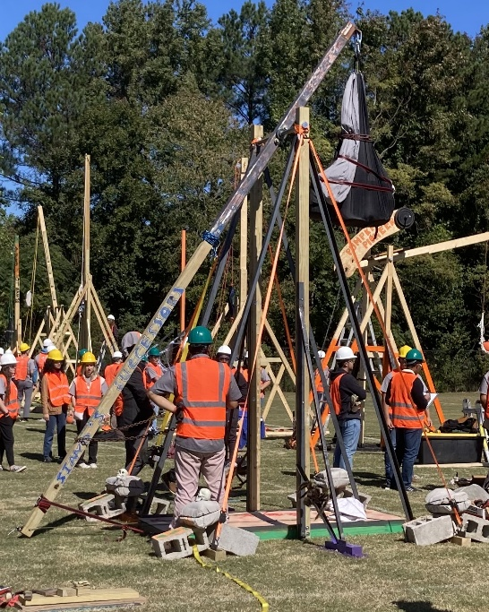 | 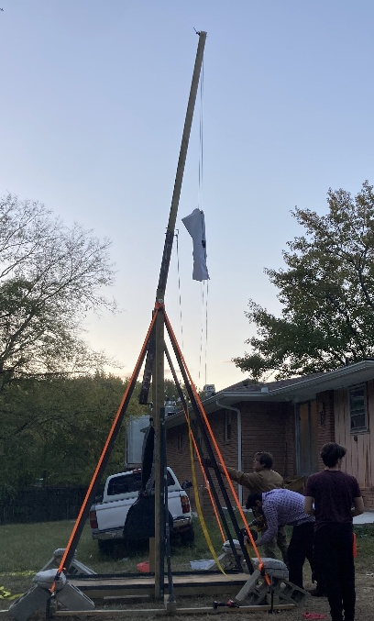

Role: Mechanical Design, CAD Modeling, Launch Optimization
Competition: Pumpkin Launch Final Round 2024
Result:2nd Place Overall
Overview
Designed and built a gravity-powered trebuchet to launch 8–11 lb pumpkins for maximum distance. The project was part of a competitive engineering event with strict safety, budget, and dimensional constraints. Our team focused on creative design, mechanical efficiency, and launch consistency.
Process
- CAD Modeling: SolidWorks design of arm geometry, sling length, and safety mechanisms
- Manual Calculations: Projectile motion, counterweight sizing, and trajectory tuning
- Build Strategy: Steel frame, rope sling, sandbag counterweights; budget-conscious material selection
- Safety & Compliance: Remote trigger, safety strap, gloves, uncocking mechanism
- Testing: Two launch attempts with real-time tuning of sling tension and arm angle
Results & Key Takeaways
- Creativity Score: 87/100 (2nd place)
- Longest Launch: 284.0 ft
- Overall Score: 249 points
- Final Ranking: 🥈 2nd Place Overall
- Learned to balance creativity, cost, and performance under pressure
- Reinforced skills in CAD, mechanical design, and hands-on prototyping
- Gained experience in safety compliance and competition logistics

Plaque Holder — Custom 3D-Printed Display Stand
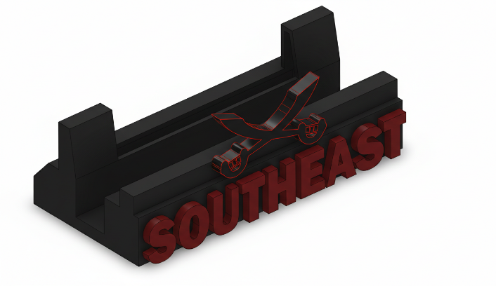 | 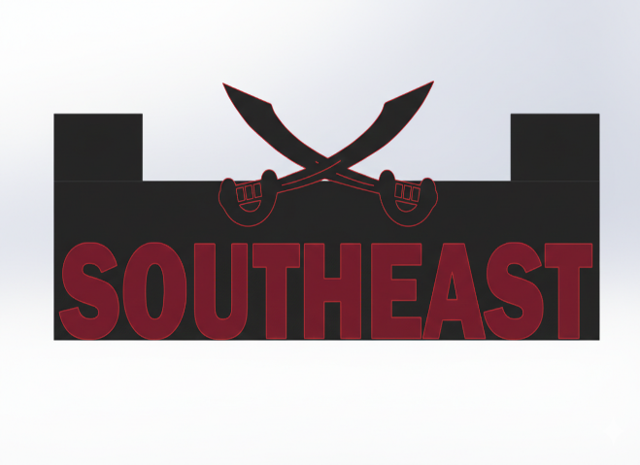
Role: CAD Modeling, Parametric Design, Engineering Documentation
Tools: SolidWorks (Part Modeling, Drafting, Rendering)
Context: Designed for high school board awards ceremony
Overview
Created a custom 3D-printed plaque holder to display award plaques during a school board ceremony. The design needed to be visually clean, stable, manufacturable on standard FDM printers, and sized precisely to the plaque dimensions. This project demonstrates my ability to translate real-world requirements into a functional, professional CAD model.
Process
- Requirements Definition:
  - Fit a specific plaque size with proper viewing angle
  - Maintain stability without excessive material use
  - Include school branding (“SOUTHEAST” + logo motif)
  - Ensure printability on a standard 200×200 mm build plate
- CAD Modeling:
  - Built a fully parametric SolidWorks model with adjustable width, angle, and lip height
  - Added fillets, chamfers, and draft angles for strength and print quality
  - Integrated embossed text and logo features for visual identity
  - Ensured proper wall thickness and support-free geometry
Results & Key Takeaways
- Delivered a functional, stable, and visually polished display stand
- Successfully printed and used during the awards ceremony
- Demonstrated strong skills in parametric modeling, design for additive manufacturing, and technical documentation
- Reinforced the importance of clear requirements, manufacturability, and aesthetic considerations in real world design work

Forward Arming and Refueling Point (FARP) — Georgia Army National Guard
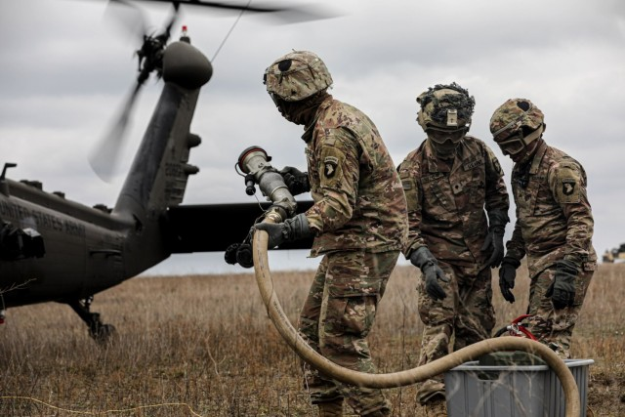
Role: Fuel Systems Setup, Safety Oversight, Aircraft Ground Coordination
Overview
Supported the setup and operation of a Forward Arming and Refueling Point (FARP) as part of a National Guard logistics mission. The operation required establishing a temporary refueling site for rotary wing aircraft, ensuring safe fuel handling, equipment readiness, and controlled aircraft movement within the landing zone.

Process
- Configured refueling equipment, hoses, pumps, grounding rods, and containment systems
- Performed safety inspections, leak checks, and environmental hazard mitigation
- Managed fuel flow paths and equipment layout to support efficient aircraft turnaround
- Ensured compliance with Army petroleum handling standards and safety protocols
- Guided helicopters into the landing zone, maintaining safe approach paths and spacing
- Coordinated with pilots and ground crew to ensure safe landing, refueling, and departure
- Maintained situational awareness of rotor wash, personnel positioning, and equipment stability
Key Takeaways
- Demonstrated leadership and responsibility in a high risk, safety critical environment
- Gained hands on experience with fuel systems, logistics, and aircraft ground operations
- Strengthened communication and coordination skills under time sensitive conditions
- Reinforced understanding of risk management, equipment reliability, and operational planning.

